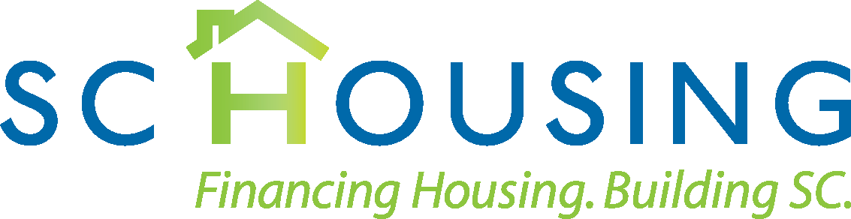

May 17, 2023

HOME and HTF Annual Rent Approval Requirements
HUD has released the 2023 HOME Income and Gross Rent Limits and Housing Trust Fund (HTF) Income and Gross Rent Limits. As a reminder, Participating Jurisdictions are required under the 2013 HOME Final Rule to review and approve rents for all HOME financed units annually throughout the affordability period. The Housing Trust Fund (HTF) Interim rule requires Grantee’s to review and approve rents annually for multi-family HTF assisted properties during their affordability period. To comply with these requirements and/or to avoid prohibition from future participation in all SC Housing programs, the following five (5) documents must be submitted:

- A completed HOME SCHTF NHTF Rent Approval Worksheet;
- A copy of the HUD HOME or HTF Rent Limits to be utilized for the property over the next twelve (12) month period.
- An approved Project Specific Utility Survey/Statewide HUD U/A Model (for each applicable bedroom type. The total monthly cost of the utility allowance must be calculated on the utility survey/Statewide HUD U/A Model document provided to SC Housing. Circle or clearly specify the amount of each allowance included in each total utility calculation. Remember to include base charges, if applicable. See note about PHA utility allowances and Green Discount/Energy Star if using.
- A copy of the current M-51 Unit Status Compliance Report for HOME units, or SRDP-21 Unit Status Compliance Report for HTF units
- A copy of the current Certificate of Property Insurance.

Owners/Management agents must submit the documents listed above for each individual property named on the HOME SCHTF NHTF Rent Approval Worksheet no later than 45 calendar days after the publication of the 2023 rent limits to allow Authority staff sufficient time to review each developments' proposed HOME rents. Any documentation submitted after the deadline may result in the denial of the any proposed rent increase.

Please note that inaccurate or incomplete forms will not be considered received and will be returned to the management company.

All of the above documents should be sent to the Compliance Monitoring Department as follows:

Electronic Submission:
Submit all documents in a ZIP file through our Secure File Exchange here: SC Housing Secure File Exchange . If you have not already registered, you will need to do so on this web page. There is a link with instructions for uploading files on the login page as well. The department to send the ZIP file to is Compliance Monitoring.

OR

By mail:
South Carolina State Housing Finance and Development Authority

Attention: Compliance Monitoring Department
300-C Outlet Pointe Boulevard Columbia, South Carolina 29210

Emailed submissions will not be accepted.

Any questions can be sent to: ComplianceDepartment@schousing.com

PHA Utility Allowances
As a reminder, under the 2013 HOME Final Rule, participating jurisdictions are no longer permitted to use the utility allowance established by the local Public Housing Agency (PHA) for HOME-assisted units for which HOME funds were committed on or after August 23, 2013.
Only an approved Project Specific Utility survey or Statewide HUD U/A Model can be used. Projects to which HOME funds were committed before the effective date of the 2013 HOME Rule may continue to use the PHA utility schedule.

Green Discount Utility Schedule
If using the “Green Discount” or Energy Star utility schedule, provide a copy of the documentation certification as performed by the appropriate third-party rater submitted with the Placed In Service application if a copy was not submitted for the 2022 Rent Approval Request. If no documentation is available, the “Green Discount” or Energy Star utility schedule cannot be used.

To sign up to receive HOME and/or HTF Rent and Income limits once published by HUD, click on the following link and then follow directions: https://www.hudexchange.info/mailinglist/

